Wynick/Tuck Gallery
401 Richmond St. W., Ground Floor
Toronto, Ontario, M5V 3A8
www.wynicktuckgallery.ca

For Immediate Release, March 2, 2007

Doris McCarthy

Selected Works, 1932-2006
March 3 – March 31, 2007
Opening: Saturday, March 3, 2007, 11 AM - 5 PM

Artist Present at 11 AM

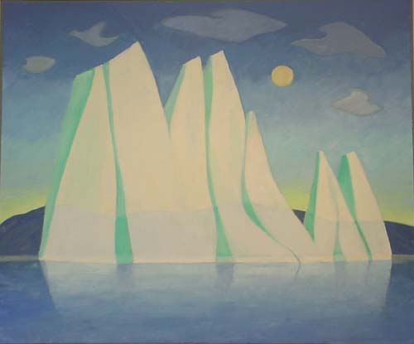
Iceberg with Moon, 2002. Oil on canvas, 48” X 60”.

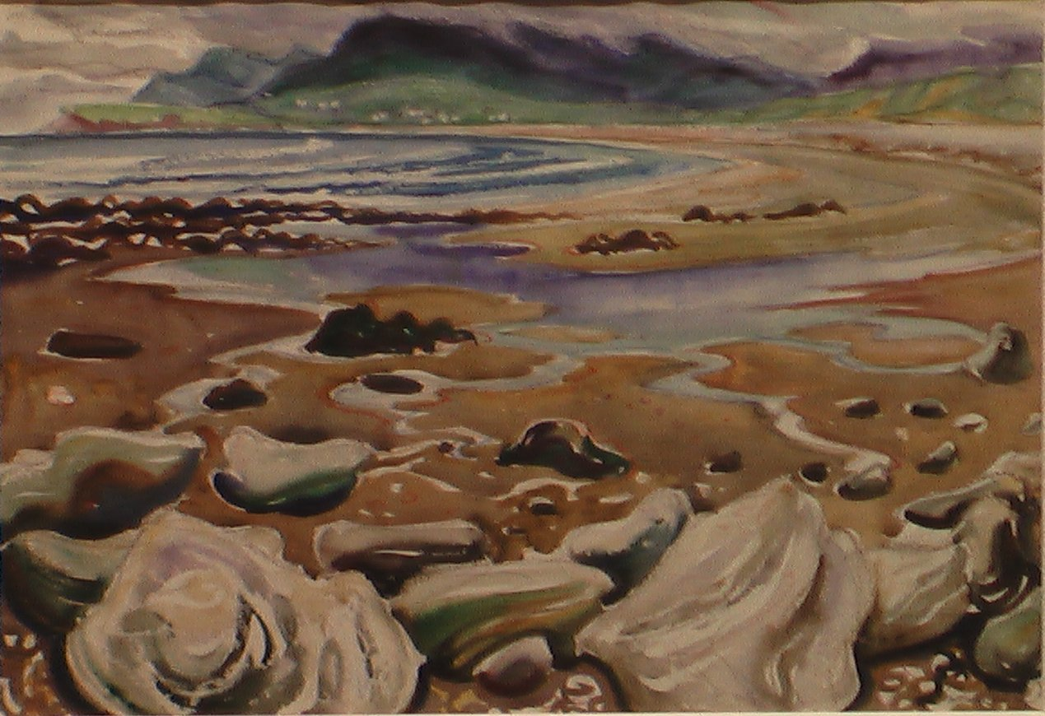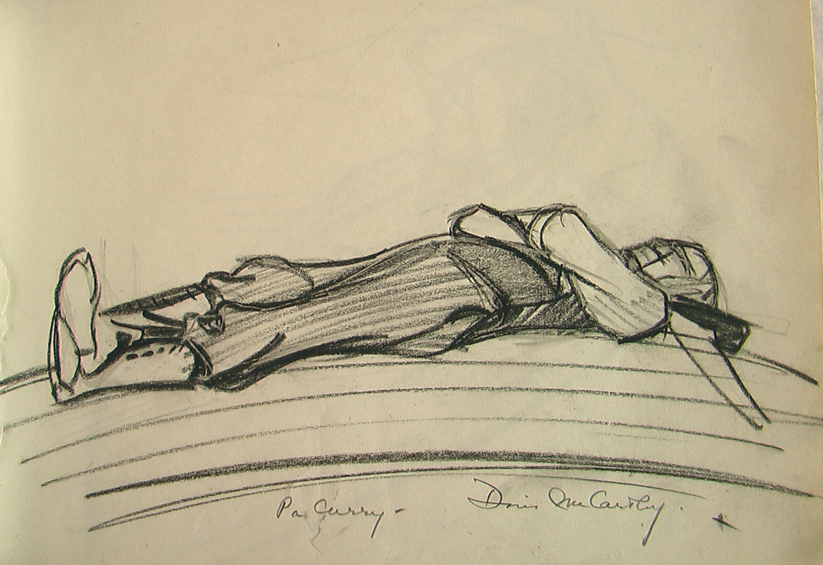
Achill Sound, Ireland, 1951. Watercolour on paper, 15” X 22”. Pa Curry, North Lake – Laying on Boat, 1932. pencil on paper, 5” X 7”.
It is our pleasure to announce an exhibition of selected works - spanning from 1932 to 2006 - by Doris McCarthy. Accompanying the new works are historical sketches and watercolours from the thirties through the sixties and recent watercolours, oil paintings, sketches and woodblock prints from the 70s through to the present.

As is explained in Doris’ most recent book, “In the past thirty years I have been true to my beginnings as Thursday’s child, traveling often, and often far…I have been across Canada…I have traveled the western coast of the continental United States…I have revisited places I love – England, Ireland, France, and Italy – and found new ones to entrance me, among them China, Morocco, Turkey, Tunisia, Hungary, Spain, Portugal, and Ukraine. When I question myself about this wandering, I believe its roots lie in Haliburton during my earliest days as an artist…When you are successful, you come to know the land, not just see it.” As a means to celebrate Doris’ love of wandering, this latest exhibition shows an exquisite geographic cross-section of work, with a number of works from the aforementioned foundational work produced at Haliburton. New watercolour sketches of Georgian Bay are also on display, complementing the rich body of selected works, mapping Doris’ commitment to her art, as well as the constant sense of playfulness she has maintained throughout her 80-year career.

Doris is the recipient of the Order of Canada and the Order of Ontario, as well as numerous fellowships and honourary doctorates from schools across Canada. In the past few years she was also the proud dedicatee of the Amadeus Choir’s Amadeus and the Artist – A Portrait of Doris McCarthy, featuring a multimedia display of Doris’ work accompanied by an original choral work, sung by the Bach Children’s Chorus. She also had the honour of being short-listed for the Lifetime Achievement Award at this year’s Untitled Art Awards, a celebration of arts in the city of Toronto. And there is now a new book about McCarthy, Doris McCarthy, My Life, a compilation of McCarthy’s two autobiographies written with Charis Wahl
For more information, please visit us on the web at www.wynicktuckgallery.ca, (updated Saturday, March 3).

