Wynick/Tuck Gallery
401 Richmond St. W., Ground Floor, Suite 128
Toronto, Ontario, M5V 3A8
www.wynicktuckgallery.ca

For immediate release, February 1, 2007.

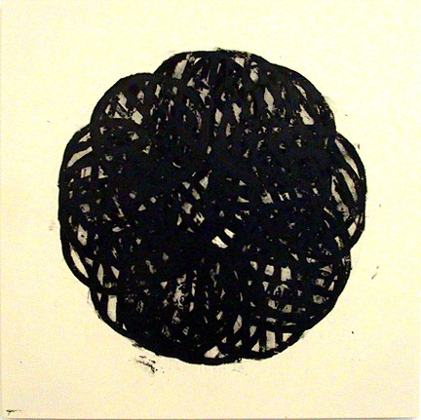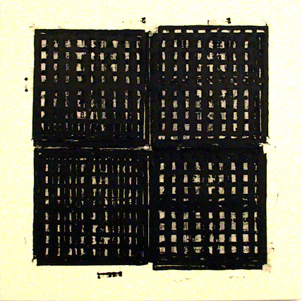

Ferguson, Twenty Drain Covers, 2006, enamel on canvas, Ferguson, Twelve Drain Covers, 2006, enamel on canvas,
48” x 48”. 48” x 48”.

Gerald Ferguson
Drain Cover Paintings
February 3 – 24, 2007
Opening, February 3
Artist Present, 2-5pm

We are pleased to announce a solo exhibition of new work by Gerald Ferguson, to be presented by the Wynick/Tuck Gallery, opening on Saturday February 3, 2007. The artist will be present between 2-5 pm.

Ferguson continues with the frottage (rubbing) technique, in this body of work using round and square drain covers as his subject. Laying down such everyday, mundane items, covering them with artist’s canvas and rolling over the canvas with black paint, Ferguson has produced rich abstractions.

Of Ferguson’s last show at Wynick/Tuck Gallery, Fencing, Gary Michael Dault noted in his Globe and Mail (February 4, 2006) review, “This new exhibition by senior Halifax-based artist Gerald Ferguson, undisputed dean of Canadian conceptual painting, is called Fencing. As is the case with all of Ferguson’s art, the works are both chest-tighteningly delicious as pleasure-giving artworks and, at the same time, disarmingly, almost arrogantly simple and spare.

Well, okay, they’re not exactly spare. One of the most absorbing of the paradoxical axes running through their making and their reception, lies, in fact, in the way the paintings seem both dumbly simple and yet present you with a teeming, titillating world of painterly incident with which to amuse yourself…. While the paintings are profoundly only what they are, fencing rolled with enamel, they also reference the great performative paintings of the canonical abstraction and minimalism.

---In the end the paintings generate a compelling binary payoff that offers the viewer just what is there while, at the same time, more or less anything you can bring to them.”

Upcoming in the spring, The Dalhousie Art Gallery in Halifax, is presenting a major survey exhibition of Ferguson’s Frottage work, 1994-2006, May 10 – July 1, 2007. A catalogue will accompany the exhibition.

