For immediate release January 13, 2006

PAUL BUTLER

Getting There is Half the Fun New Works
North Gallery

KIM OUELLETTE

Wool Drawings New Works
South Gallery

January 14 – February 1

Opening Saturday, January 14. Artists present from 2 – 5 pm.

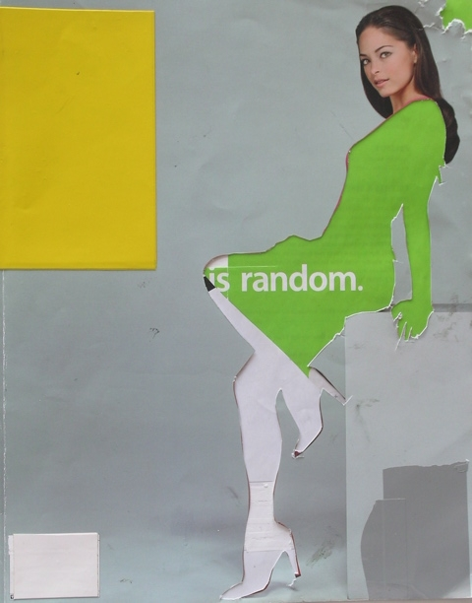

Getting There is Half the Fun features works from the “Readymades” collage series, as well as Books of Things to Do, works that are meant to explore the artist’s relationship to the art-making process. Looking to Duchamp's concept of the “Readymade” – finding art in the everyday – Butler applies the process to his collage practice. Collage parties are held by Butler across Canada and internationally, where artists come together to create in an informal setting. In this new set of works, Butler uses the collage party as a readymade studio, gathering the remnants from other artist’s efforts - left behind tears and cutouts arranged in no particular way – then through his own intervention as artist, makes these forgotten bits and pieces art in their own right. Butler comically refers to this process as “collaging degree zero,” though it does mark a rather serious refinement in the way Butler has done collage in the past.

Butler has recently had solo shows at Blanket Gallery in Vancouver and Cream Gallery in Winnipeg, and also has a major upcoming solo exhibition at White Columns, New York’s oldest alternative art space. He has recently held collage parties in Vancouver, Edmonton, Halifax, Auckland, Berlin, New York, and Los Angeles, and has parties coming up at the Cooper Gallery, Dundee, Scotland (January 27, 2006), ZieherSmith in New York (June 2006), MoCA in Los Angeles (July 2006), Pierre-François Ouellette Art Contemporain in Montreal (TBD), and MOCCA in Toronto (August 2006). When he is not producing his own work or holding parties, Paul also serves as the director for the Winnipeg-based othergallery.

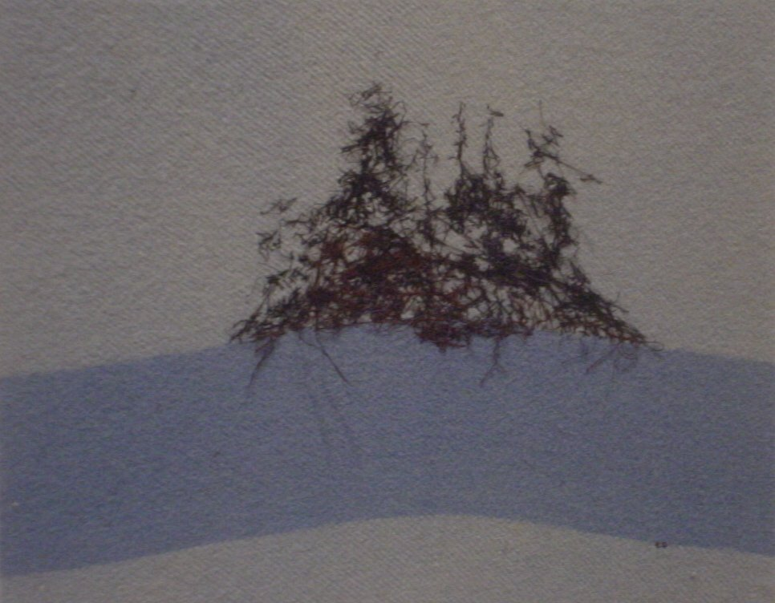

We are pleased to present the first solo exhibition at our gallery of the work of Kim Ouellette.

Sewn onto scraps of recovered blankets, Kim Ouellette’s vignettes and abstracted landscapes harken back to a time of explorers and pioneers. The Hudson Bay blankets recall memories of warmth and safety, in overt contrast to the snowy mountains and harsh conditions that Ouellette “draws” on to her woollen canvases. Though Ouellette now lives just outside of Atlanta, Georgia, the native-Winnipeg artist’s spare works evoke both the mental and physical landscapes of Canada.

This exhibition, somewhat of a survey of her oeuvre, shows Ouellette experimenting with the thread in an unorthodox and painterly manner, utilizing the texture and colour of the blankets and their inherent nature. As well as referencing the landscape and related tales Ouellette moves successfully into pure abstraction.

For more information: Katrina Enros, 416-504-8716 x21
Please visit, www.wynicktuckgallery.ca

