For immediate release, February 3, 2006.

Gerald Ferguson

Fencing
New Paintings
North and South Galleries

Artists Present #3
Janice Gurney presents:

Sally Späth
In-Site Installation
Project Room

February 4 – February 26, 2006.

Opening: February 4, 2006, 2-5 pm

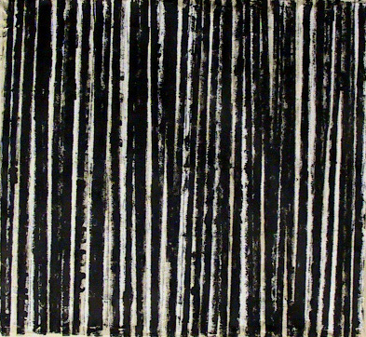

Ferguson, Gerald
Fence 7, 2005
enamel on canvas 48 X 53 in.

We are pleased to announce a solo exhibition of new work by Gerald Ferguson, to be presented by the Wynick/Tuck Gallery, opening on Saturday February 4, 2006. The artist will be present between 2-5 pm.

Ferguson continues with the frottage (rubbing) technique, in this body of work using various fencing material as his subject. Laying down such everyday, mundane items as wooden snow fencing and lattice or aluminium fence posts, covering them with artist’s canvas and rolling over the canvas with black paint, Ferguson has produced rich, linear abstractions. As well, and complimenting the Fencing paintings, Ferguson has produced five anonymous, somewhat unsettling portraits, using a stencilling process and referring to the amorphous forms of antique boundary markers, (carved stone torsos), used in past times to mark the four corners of a fenced in area.

Of Ferguson’s last show, Door Mats, Gary Michael Dault noted in his Globe and Mail (February 5, 2005) review, “The resulting “footage” paintings are among Ferguson’s finest works to date. [...] You can clearly see the impress of the door mat in all of the finished works. You can also see everything else, from Goya to Barnett Newman and Richard Serra. The Door Mats are encyclopedic. And endlessly fine.”

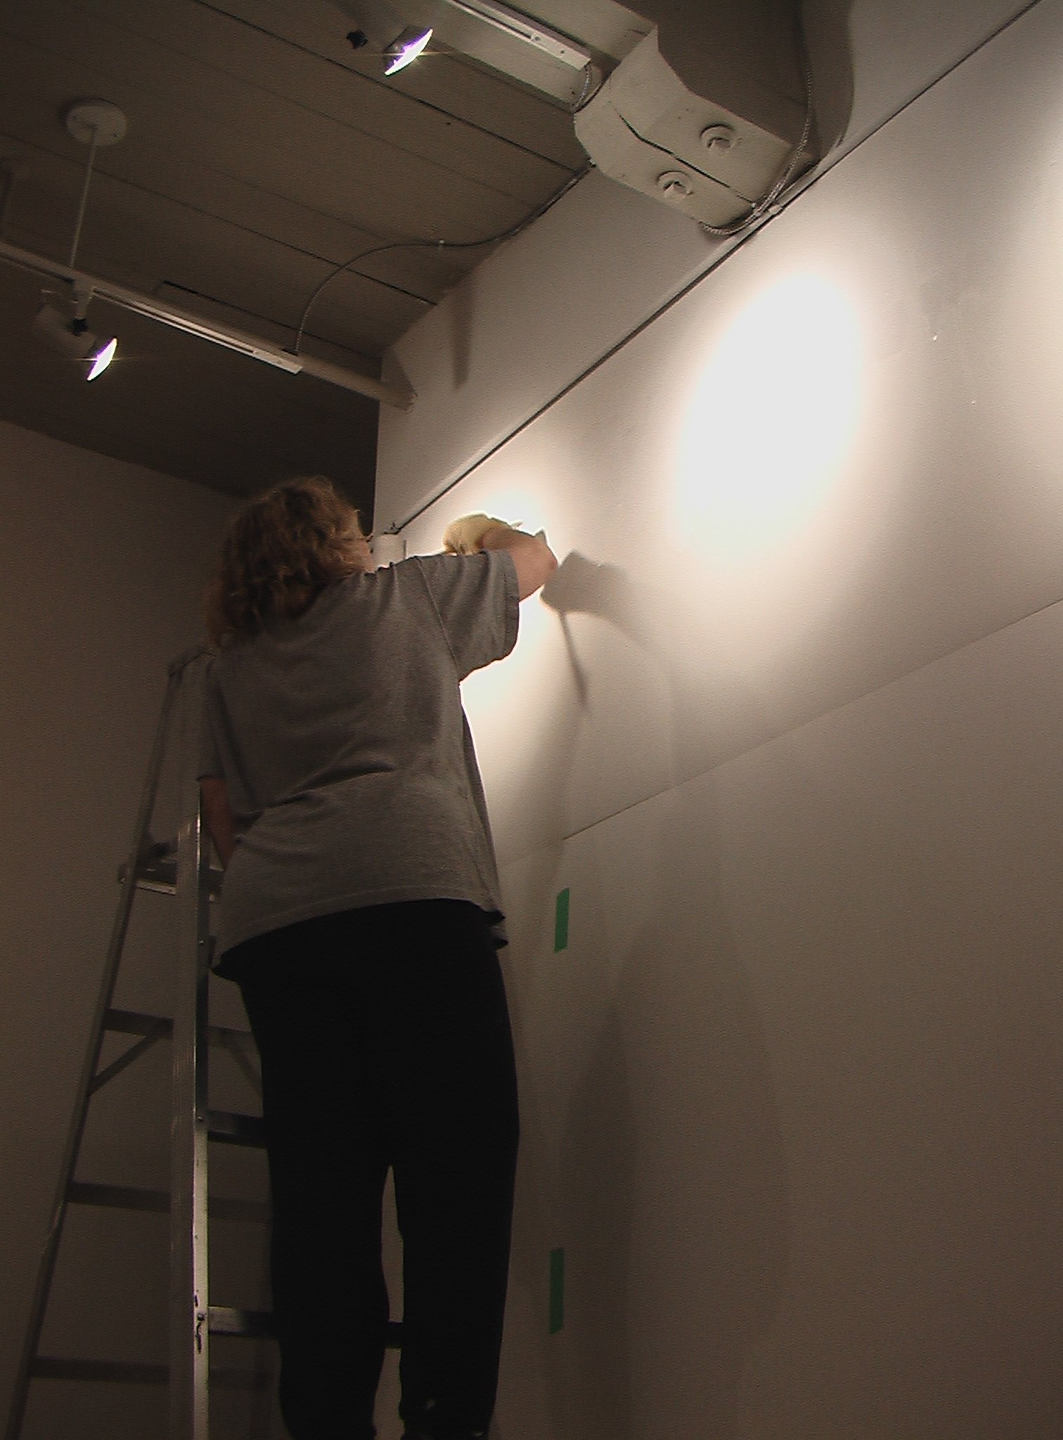

Artist Sally Späth at work in the Project Room.

We are also pleased to announce an exhibition of artist Sally Späth’s work at Wynick/Tuck Gallery, as part of our ongoing Artists Present series. The artist will be present during the February 4th opening, from 2-5 pm.

Späth’s work uses sheets of mylar, painted around with varying shades of white; the mylar is then removed, leaving the paint solitary on the wall. It is a play on presence and absence, quiet contemplation, and subtlety in a medium that usually announces and seduces with the aide of colours and textured brush strokes, whilst Späth relies on neither. She is a member of the artists’ collective Painting Disorders, and has exhibited with them since 1994. More recently she also had a major, solo exhibition at the Art Gallery of York University in 2003.

Gallery artist Janice Gurney has selected the painting work of Sally Späth, who has chosen to create this work in-situ. Gurney, commenting on her choice of Späth notes, “...the whole of her painting feels as if it is never entirely available in the present moment. There is always a void. To a viewer, the work can sometimes appear as an after-image; something you feel that you are seeing but know is not there. As its physical presence becomes an absence, the concreteness of now drifts into the fleetingness of memory. Sally uses paint both as evidence of this past and a declaration of the present. [...] I always have the sense that it is something that had another existence in another location, with another appearance in another time. Yet the painting exists right there in front of you too - nothing is hidden.”

For further information you can visit our website at www.wynicktuckgallery.ca,

or contact Katrina Enros, Assistant to the Directors
416.504.8716 x.21

