Wynick/Tuck Gallery, Fall exhibitions, for immediate release, Sept 10, 2005
Sheila Ayearst and Colette Laliberté
Opening: Saturday, September 10, 2-5pm., artists present

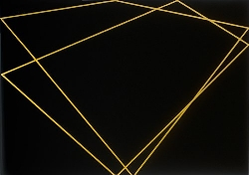

Sheila Ayearst
A Black No
New Paintings
September 10 – October 8, 2005

This exhibition is a continuation of Ayearst’s ongoing interest in space, examining the inherent two-dimensionality of the painted space, coupled with its frequent ambition to create the illusion of depth, of the third dimension. As with many of Ayearst’s previous works, A Black No uses the concept of the superhighway as an icon to recapture historical notions of authority and security within the context of painting.
To these works Ayearst applies the mathematical Fibonacci sequence; this concept of the Golden Ratio not only governs the proportions of the shells of snails and the petals of flowers, but informs the beautiful proportions found in Renaissance paintings. Here Ayearst applies the ratio to a visual concept more common to contemporary living, the glowing yellow markings on black highways. The lines are stilled and warped, forming open and closed structures which seem to vibrate, moving in and out of the picture plane.

Two paintings by Sheila Ayearst are concurrently on view (opening Friday, September 9, 8pm.) in a group show, Dimensionality, curated by Andy Patton at YYZ Artist Outlet in Toronto. The exhibition will travel to Forest City Gallery in London, Ontario later this year.

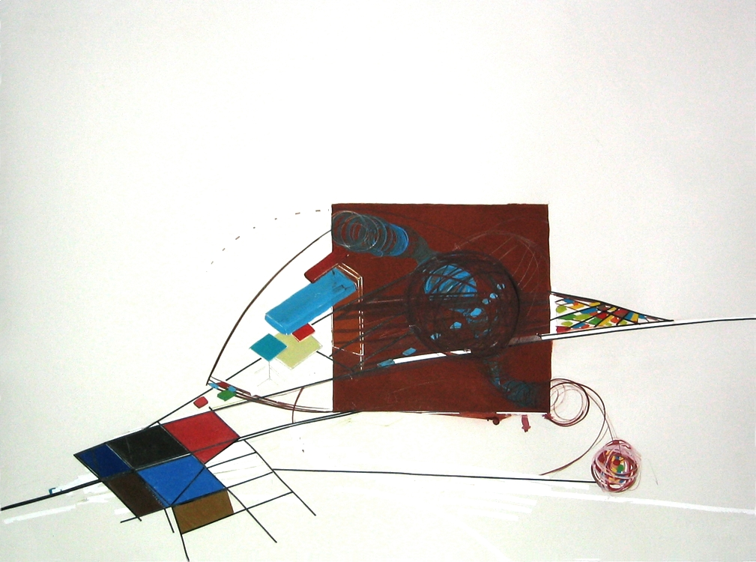

Colette Laliberté
Conundrum
New Work
September 10 – October 8, 2005

Conundrum is a series of paintings on paper in the South Gallery and a site specific wall painting installation set in the gallery’s Project Room. The paintings are fictitious topographies, capturing the movement and speed Laliberté imagines of information playfully spinning and whizzing through cyberspace. The images are constructed by combining different perspective views and elevations within the picture plane. The flat, coloured swatches not only refer to the use of digital reproduction, but also allude to the history of modern colour field painting. Again two-dimensionality and three-dimensionality compete for space in the picture plane, while Laliberté also contends with the more abstract concept of the fourth dimension, informed largely by the work of Russian Suprematist Kasimir Malevich and of Theo van Doesburgh.

Laliberté has recently exhibited her work in a solo exhibition at the Durham Art Gallery and at the Museé des Beaux-Arts de Sherbrooke. In October 2004, she participated in an international residency in Brooklyn, NY at The Triangle Artist Workshop, was also featured in Mix Magazine, and contributed to TFO Television series “Fou d’Art”.

For further information on our site, go to; http://www.wynicktuckgallery.ca/

