For immediate release November 25, 2005

CORA CLUETT

Always As If, New Paintings
North Gallery
November 19 – December 17, 2005

Four oil paintings on canvas, recently returned from the Albright-Knox Gallery, Buffalo, Beyond / In Western New York 2005 biennale, and nine small oil paintings on resin comprise Cluett’s solo exhibition, continuing through December 17.

In her review of the summer, Albright Knox exhibition, Sarah Milroy, Art Critic at the The Globe and Mail, referred to Cluett’s work as “...appealingly sticky-looking abstractions, their monochromatic, candy-coloured glazes ruptured by blisters, welts or scars of pigment...”, whilst Holly E. Hughes, project curator for the Albright-Knox lauded the works as “...images which explode with sexuality and color...”.

In her new, small oil on resin works, Cluett built up layers of resin to form the “stretchers” on which she layers oil glazes. All of Cluett’s work reference not only the history of modernist painting, but make allusions to the body, the surface of the skin, and what lies beneath. Cluett says of her work; “In the construction of my paintings I stamp a mark, in grid formation, into a wet surface of paint to create surfaces that reference the modernist grid whilst subverting its overt order. This stamping process causes the grid to slip out of square and the paint to ooze, cut, pull, and depress. I then use repeated glazing techniques to fuse and flood the surface with layers of color.”

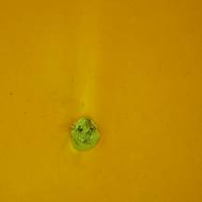

JACLYN SHOUB

Snapshot Studies, New Paintings
Project Room
November 19 – December 17, 2005

Having recently returned from a major solo survey exhibition, at the Art Gallery of Nova Scotia this past summer, Jaclyn Shoub’s small paintings - Snapshot Studies - are now on exhibition in Wynick/Tuck Gallery’s Project Room.

Though their small scale may seem diminutive, these small studies only amplify Shoub’s abilities as a painter. The handling of minute details and transitions from light to dark, particularly in those works that portray the shadows of dusk, truly bear the earmarks of an adept painter.

In a recent statement about her work Shoub says, “…These quick studies are derived from my catalogue of images, which form the elements of my larger pieces. By juxtaposing these very different working methods I hope to further expand and question the relationship between photographic and painted imagery. My work focuses on the architecture and landscape of the transitional area between urban and rural settings. The transition, dislocation and isolation experienced driving through this sprawling landscape is used in these works as a metaphor for change and resulting broader feelings of anxiety and uncertainty... “.

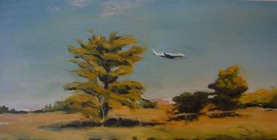

For more information: visit www.wynicktuckgallery.ca

ANGELA LEACH

Shimmy
Artist Talk, Sunday, November 27, 2:45 pm.
At DMG, the Public Gallery at the University of Toronto, Scarborough Campus
For more information and directions go to their website at: www.utsc.utoronto.ca/dmg

