Kelly Mark

“Drawn”
April 9 – April 30
Opening: Saturday April 9, 2005
Artist present from 2-5 pm

We are pleased to announce an exhibition of Kelly Mark’s new letraset and graphite drawings, as well as her new, two channel, video installation, Hiccup #3 (Houston).

Mark’s new works are developments on earlier themes; in her letraset drawings, conceived in 2001-02, Mark uses leftover letreset, now employing it to make 2 continuous 16 foot line drawings –drawings that continue from one frame to another. Works in the Hiccup series have been exhibited in Toronto (a seven channel work at the Power Plant Gallery), Canada and Birmingham, England. Mark’s past graphite works have employed a whole variety of objects, from rolling pins to chess sets. The new graphite works will include Drawing of a Study for a Masterpiece and Drawing of a Limited Edition Collector Plate Series. In Hiccup #3, (Houston), Mark explores once more the theme of passing time, and our experiences within routine, seemingly natural gestures and actions.

Mark has been ever-busy since her last showing at Wynick/Tuck, maintaining her online curation project www.samplesize.ca, and partaking in various projects, including the Dead Nature/la vie immobile exhibition at The Ottawa Art Gallery, the Middlesbrough Institute of Modern Art’s audio publication QSL, as well as various artist talks in Canada and the U.S. Wynick/Tuck’s exhibition runs concurrently with several other Mark exhibitions in the month of April including YYZ Gallery’s exhibition horror/suspense/romance/porn/kung-Fu, the Power Plant-sponsored Glow House project, and a group show at Buffalo’s Albright-Knox Gallery entitled Beyond - In Western New York. Kelly’s curation project Free Sample at the Mount Saint Vincent University Art Gallery also runs during the month of April. Upcoming for Mark are the group shows: The Hidden Side of Appearances at the Musee d’Art Contemporain (Montreal) in May, Fuzzy at the Oakville Galleries in September, as well as Situation Comedy curated by Michael Rooks and circulated by the ICI in New York starting at the Contemporary Museum in Honolulu in September and then moving onto the Chicago Cultural Center in the Spring.

Concurrent Kelly Mark Exhibitions:
Glow House #3 Sponsored by the Power Plant
(Located at 323 Palmerston Blvd., N. of College)
Opens Thursday, April 7, 2005
April 7 – April 23

horror/suspense/romance/porn/kung-fu YYZ Artist’s Outlet
(Located at 401 Richmond St. W., Suite 140)
Opens Friday, April 8, 2005 8 pm – 11 pm
April 8 – May 21

Kelly Mark’s website: http://www.ireallyshould.com

David Askevold
Two Hanks
April 9 – April 30
Opening: Saturday April 9, 2005

We are pleased to announce the Two Hanks installation by David Askevold. The installation includes stills from the film, scematic drawings for the performance and the Two Hanks video

Two Hanks is the manifestation of Askevold’s desire to bring two musicians that he loves, both long gone from this world, to the same stage. Hank Snow from Queen’s County, Nova Scotia and Hank Williams from Georgina, Alabama both informed previous art projects of Askevold’s: Williams for the ghost-like feel of “Ramblin’ Man” that initially inspired the loose-sketches for an incantation, and Snow for his influence on one of Askevold’s earlier works, “Poltergeist” (a collaborative work with Mike Kelley). The Hanks’ music, and their ghosts, converge in Askevold’s live performance which took place at the CANADA gallery in New York on May 2, 2003.

The video installation of Two Hanks was shown in 2004 at Kling & Bang Galleri, Reykjavik, Iceland, and in 2003 at the CANADA gallery in New York, New York. In the past year Askevold has had a solo show of new cibachrome prints at the Mandarin gallery in L.A., as well as a group show at Prince Edward Island’s Confederation Gallery entitled Littoral Documents. Upcoming for 2005 is yet another CANADA show, entitled The Immediate Landscape, from May 20 – June 20.

For more information on Kelly Mark or David Askevold, as well as other current work in the gallery, please call, or visit our website:
http://www.wynicktuckgallery.ca/

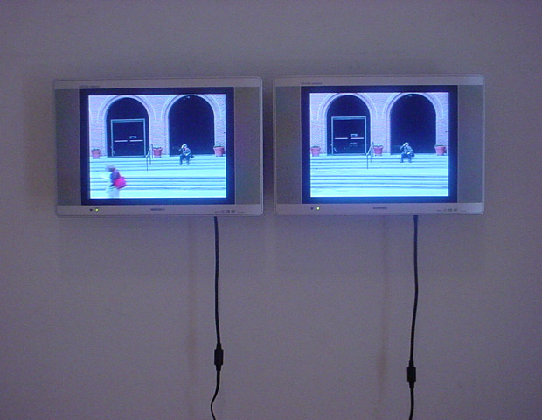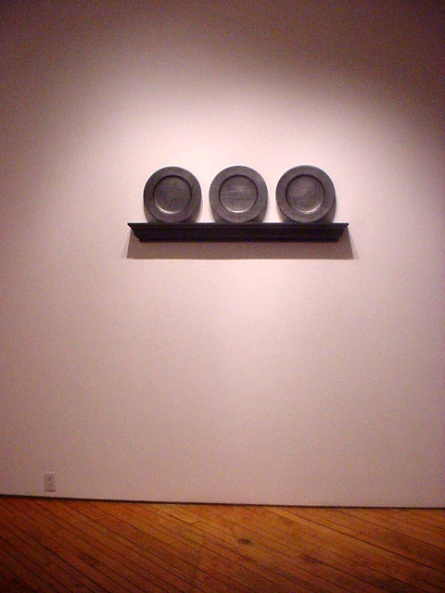

Kelly Mark Kelly Mark
Hiccup #3 (Houston), 2004 Drawing of a Limited Edition Collector Plate Series, Ed.1/3, 2005
2 channel DVD-LCD combination graphite on wood with mat spray finish
4:41 minutes, colour, silent 48 X 16 X 5 inches

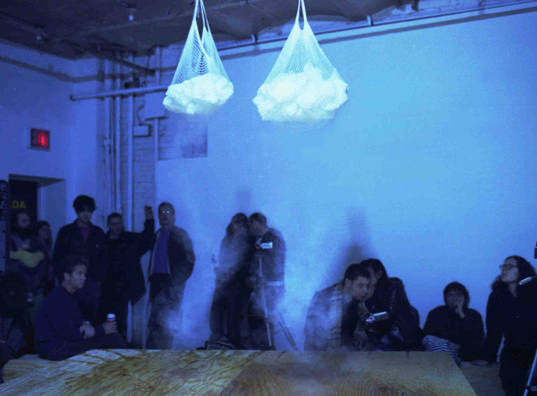

David Askevold
Untitled Still, 2003
from the film, Two Hanks
c-print
30 X 40 inches

