For Immediate Release, March 3, 2006

Doris McCarthy

New Oil Paintings, Watercolours, Sketches
March 4 – April 1, 2006
Opening: Saturday, March 4, 2006, 11 AM - 5 PM

Artist Present from 11 AM – 12:30 PM & 2:30 PM – 4 PM

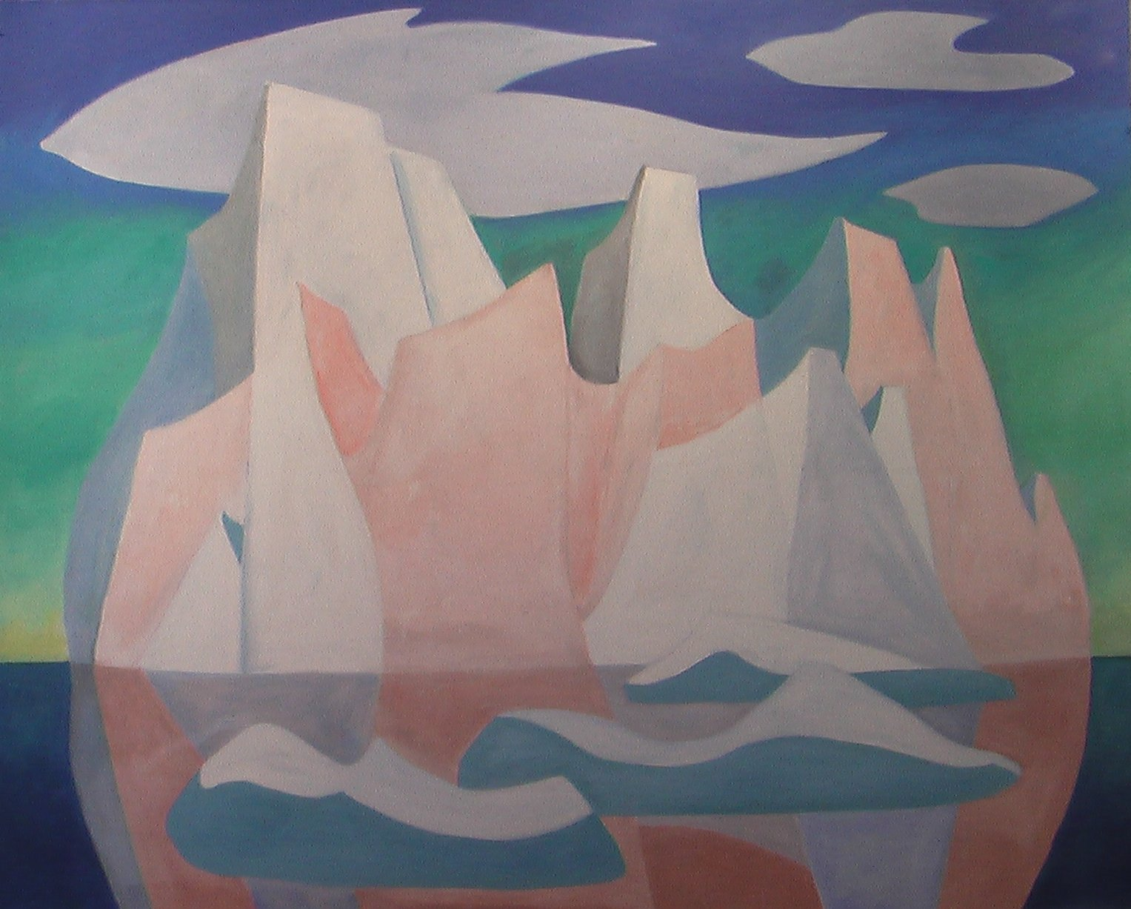

Doris McCarthy
The Pink Iceberg, 2006
oil on canvas
60” X 72”

It is our pleasure to announce an exhibition of new works by Doris McCarthy. Accompanying these works are historical sketches and watercolours from the thirties through the sixties, featuring her trips to Newfoundland, Connemara - Ireland and her very first sketching trip with Ethel Curry to North Lake, Haliburton.

Doris once said, “The real function of the artist is to give fresh vision to their own generation.” Her new works continue to exhibit a bold experimentalism, bearing witness to the reasons for the longevity of her career over the years. The new icebergs and Georgian Bay landscapes are complimented by the inclusion of various historical works, mapping Doris’ commitment to her art, and a constant sense of playfulness throughout. The figural nature of the early North Lake and Newfoundland works offers a rare intimacy.

Doris is the recipient of the Order of Canada and the Order of Ontario, as well as numerous fellowships and honourary doctorates from schools across Canada. This past year she was also the proud dedicatee of the Amadeus Choir’s Amadeus and the Artist – A Portrait of Doris McCarthy, featuring a multimedia display of Doris’ work accompanied by an original choral work, sung by the Bach Children’s Chorus. She also had the honour of being short-listed for the Lifetime Achievement Award at this year’s Untitled Art Awards, a celebration of arts in the city of Toronto.

For more information, please visit us on the web at www.wynicktuckgallery.ca

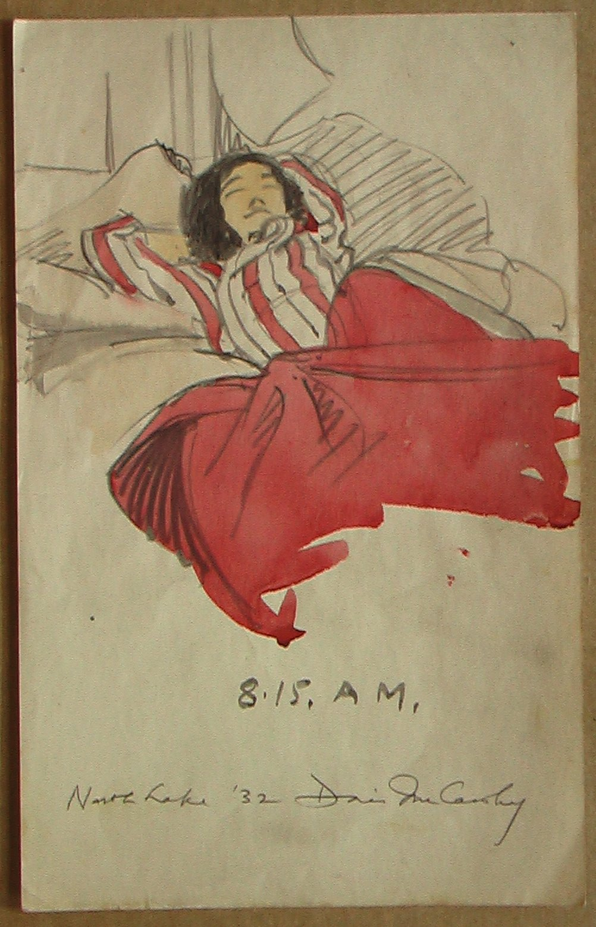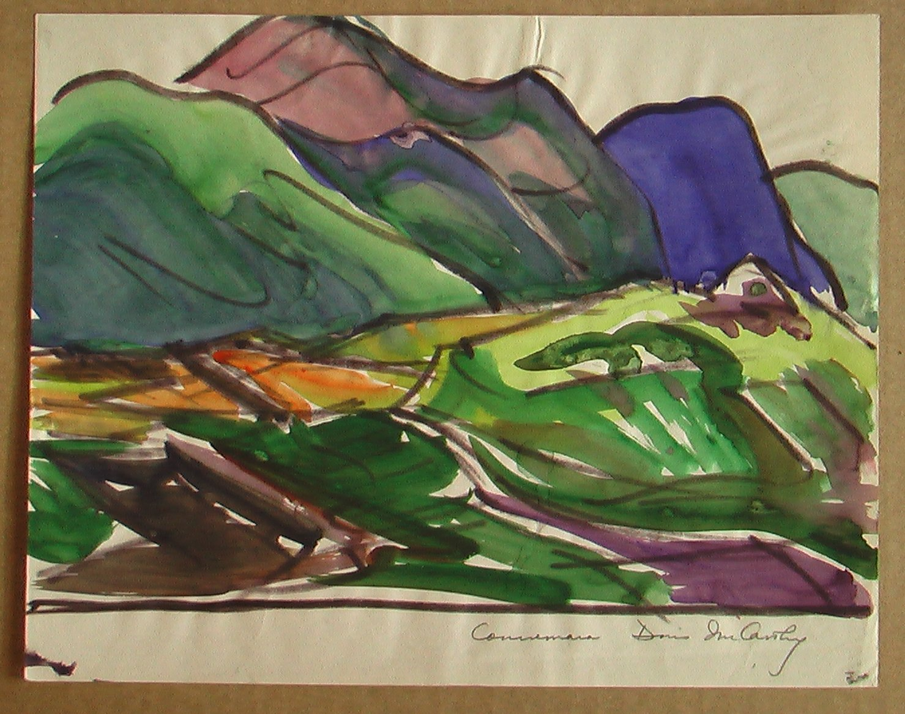
Doris McCarthy Doris McCarthy
8:15 AM, North Lake, 1932 Connemara #2, 1950
crayon and graphite on paper marker and watercolour on paper
8” X 5” 8 ¾ ” X 10 ½ ”

