Wynick/Tuck Gallery
401 Richmond St. W., Ground Floor
Toronto, Ontario, M5V 3A8
www.wynicktuckgallery.ca

For Immediate release, September 8, 2006.

September 9 – October 7
Opening: Saturday September 9, 2006, 2-5 pm
Artists present

Jonathan Johnson
New Paintings
North Gallery

Janice Gurney
Punctuation in Translation, New Works
Project Room

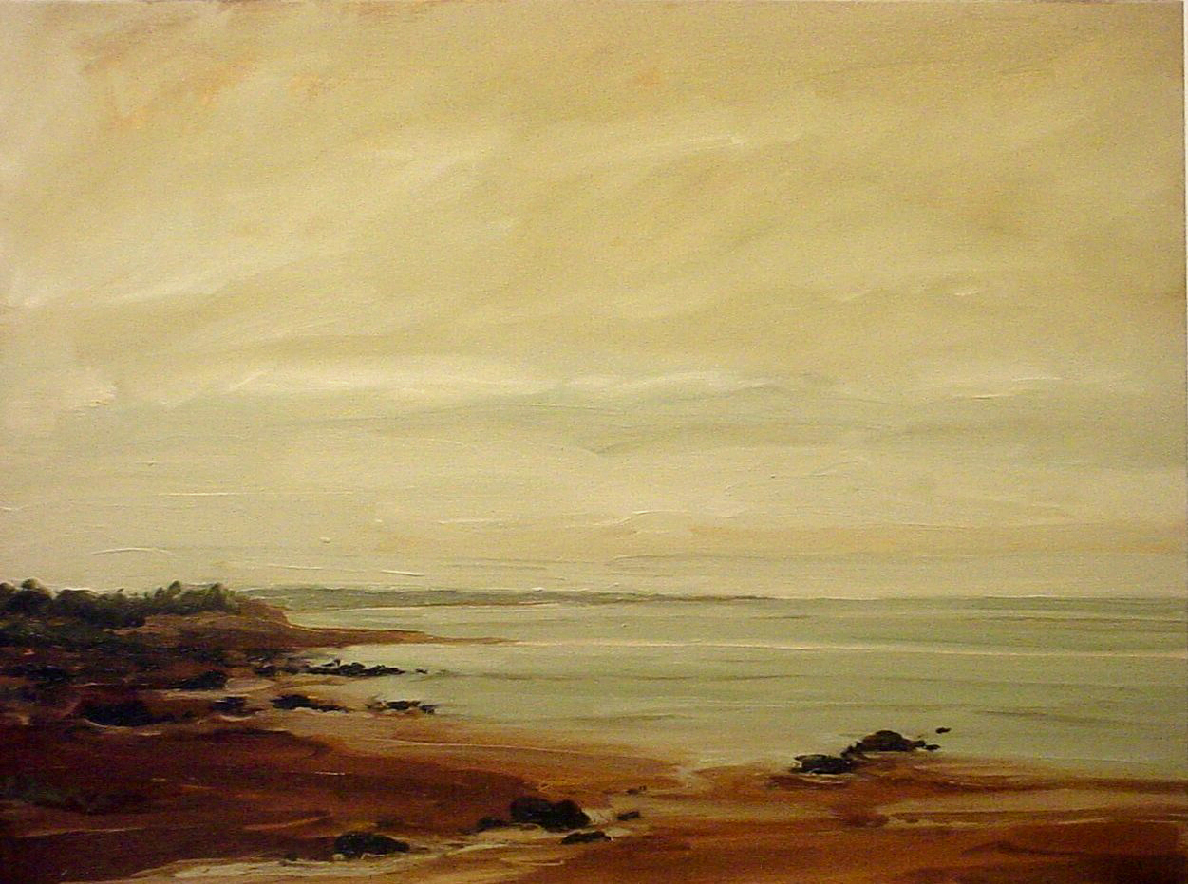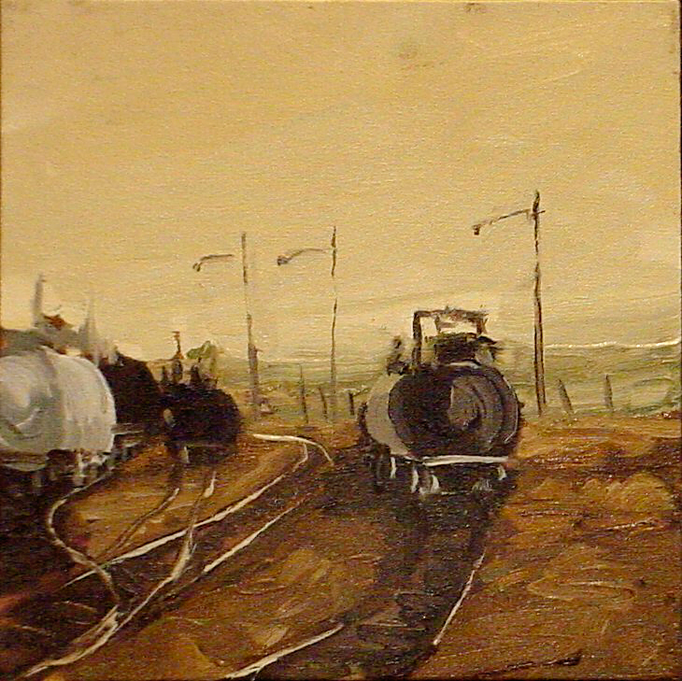
Jonathan Johnson Jonathan Johnson
Inlet Beach, 2006, oil on canvas, 36” x 48” C-Train Study, 2006, oil on canvas, 12” x 12”

We are pleased to announce an exhibition of new paintings by Jonathan Johnson, opening on Saturday, September 9, 2006 from 2-5 pm. Jonathan will be present, 2-5pm.

This is Johnson’s first solo exhibition with the Wynick/Tuck Gallery, though his works have been shown at the gallery since 2004. This new body of work for this exhibition is compelling and powerful. Embued with a tough beauty, Johnson’s work focuses on the urban edges, railway lands, highway and railway overpasses, city skylines, sometimes moving further into the rural expanses of the Maritimes. As a young contemporary painter working with current painting issues, Johnson says that he also references past artists in his work. “ ‘---how they make marks on the canvas, how they compose their paintings’ ----In Johnson’s paintings the buildings are represented by single brush strokes. Up close, they appear to be simple strokes of colour. But view the painting from further away, and these transform into buildings, roads and bridges–“ The Daily News, Halifax.

Quoting from Bernard Riordon, Director of the Beaverbrook Art Gallery in Fredericton, New Brunswick, from the exhibition program for Johnson’s solo exhibition organized by the Beaverbrook in 2004; “His work exemplifies the traditions of landscape painting with a very bold and free style that captivates ‘time and place’ and has a special impact on the viewer. His landscapes and cityscapes, without the presence of humans, create a feeling of time stopping and a stillness that provides us with a desire to reflect on and appreciate our natural and our built environments.”

Johnson has recently been shortlisted for this year’s RBC Canadian Painting Competition, the eighth annual, and is among the 16 semi finalists. Paintings were chosen from more than 1,500 works by 611 artists across the country. Johnson is the only Atlantic Canadian named in a coast to coast list of Canadian competitors. The RBC Canadian Painting Competition was juried by artists, public gallery directors and curators from across Canada.

Paintings by the semi-finalists make up a major exhibition to be shown at public galleries across Canada, including, Kitchener-Waterloo Art Gallery, Musée d'art contemporain de Montréal, Art Gallery of Calgary, the Contemporary Art Gallery in Vancouver and the Museum of Contemporary Art(MOCCA), Toronto, (which also opens this Saturday at 2-5pm).

The RBC Canadian Painting Competition is a tribute to Canada's artistic talent. The goal of the competition is to support and nurture Canadian visual artists early in their career by providing them with a forum to display their artistic talent to the country and hopefully open doors to future opportunity. The competition will award one national prize of $25,000 and two honourable mentions who will receive $15,000 each. The winning paintings of 2006 will become part of RBC Financial Group's Canadian art collection comprised of more than 4000 works of distinguished art collected over the past 100 years.

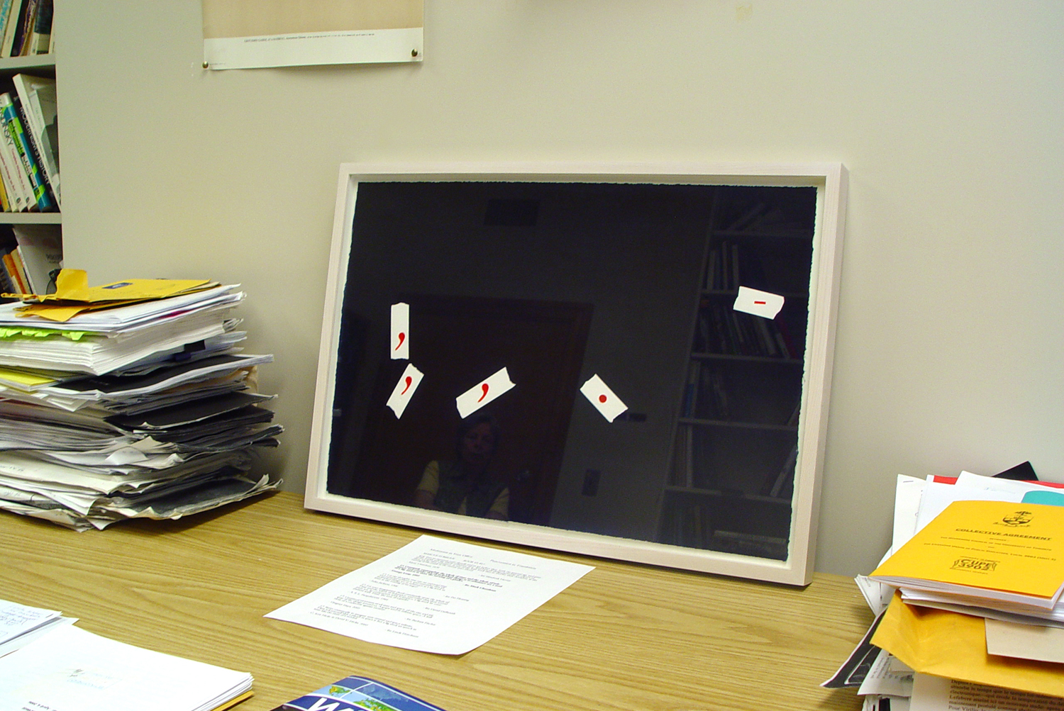
Janice Gurney
Meditation in Your Office, 2006
giclee print on watercolour paper 15" x 22"

We are also pleased to announce an exhibition of Janice Gurney’s new work, in her show entitled Punctuation as Translation. Below, Gurney explains the impetus behind the exhibition:

“The exhibition Punctuation in Translation is made up of eleven acrylic paintings on paper in which I have painted only the punctuation marks from eleven different English translations of the same meditation, Book10.17 from The Meditations of Marcus Aurelius. These translations are from the books of the meditations in my collection and span a time period from 1634, when the first was printed, until 2006, when the latest was published.
I am fascinated by how the thoughts of Marcus Aurelius, emperor of Rome from 161 - 180, continue to resonate over time. They have been preserved in many different translations, becoming a record of both permanence and change. One structure that places a different emphasis on the same meaning is punctuation, represented by the difference in the number and placement of the punctuation marks in various translations.
In April, 2006 I asked six people to place one of my "punctuation in translation" paintings in their office at the University of Toronto. The current exhibition at Wynick/Tuck Gallery includes two images of the paintings in the offices. In one photograph the painting seems to punctuate the jumble of books and papers in the room. In the other photograph the punctuation marks float over bookshelves that are reflected in the glass covering the painting.”

Other Gallery Artists News and Projects:

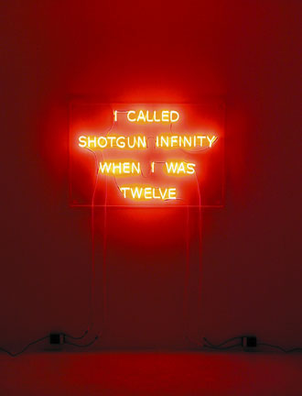
Kelly Mark
I Called Shotgun Infinity When I Was Twelve, 2006
48.5 x 32 x 3 1/2 in - edition of 3

Gallery artist Kelly Mark is participating in this year’s first annual Toronto Nuit Blanche on September 30th. Downtown Toronto will be subdivided into 4 major sections for visitors to walk around all night long, from 7 p.m. on the evening of the 30th, until 7 am on the morning of October 1st. Mark’s neon work Hold that Thought (2006) will be installed at the Church of the Redeemer, located at Avenue Road & Bloor.

Mark’s earlier sound work HUM will be aired in 401 Richmond’s main hallway, outside our premises, all night. And we will exhibit one of Mark’s videos in our Project Room Window during the same night. 401 will be open all night for Nuit Blanche. The Mark work shown above will be featured in our booth at The Toronto International Art Fair, TIAF, November 9-13.

Kim Adams interactive work, Bugs and Dragons, continues at the Art Gallery of Ontario. Adams conceived Bugs and Dragons, an installation of two interrelated components: the Dragon Wagon, a mobile cart that generates art activities for AGO visitors throughout the galleries; and wrecking yard elements that become a “painting” on the wall with a seating area containing Adams-designed “chairs” that invite us to take a moment to view our surroundings.

Watch out for more “chairs” by Adams this October and November in our Project Room and at our booth at this years’ edition 0f the TIAF.

Four Gallery artists, painters, Nicole Collins, Cora Cluett, Angela Leach and Monica Tap have been selected for inclusion in the exhibition Pulse opening at the Mount Saint Vincent University Art Gallery in Halifax, October 14. We’ll have more about this show, which juxtaposes 5 painters and 5 video artists, in our next newsletter.

John Hall had work included in a two-person exhibition this past summer with Joice Hall at the Art Gallery of the South Okanagan in Penticton, July and August. Ascending Pleasures III, a solo exhibition, opens at the Prairie Gallery in Grande Prairie, Alberta in September. In November, Hall will be curating an exhibition titled “SEE: Three Decades of Realist Painting” at the Mezzanine Gallery at the University of Calgary

We’re pleased to announce that, Puss ‘n Boots, 2003, acrylic on canvas, 60” x 104”, one of the two major Carol Wainio paintings that have been on exhibit at the National Gallery during recent months, has been approved for acquisition and now is part of the National Gallery’s permanent collection. Several new small paintings that preview Wainio’s next body of work are currently on view at our gallery.

For more information:
Karen Danis, 416-504-8716, x21
wtg@wynicktuckgallery.ca

