For Immediate release, July 14, 2006.

informal ideas: 01-06, stand

including: Kim Adams, Nicole Collins, Greg Curnoe, Gerald Ferguson, Cal Lane, Doris McCarthy, Dyan Marie, Kelly Mark, Kim Ouellette, Ted Rettig, Michael Snow, Monica Tap, Carol Wainio, among others.

stand of trees, light stand, bike stand, etc.
stand by, stand down, stand for, stand in, stand off, stand on, stand out, stand over, stand to, stand up, etc.
stand a chance, stand (one’s) ground, stand on (one’s) own feet/two feet, stand pat, stand to reason, stand up for, stand up to, stand up with, etc.

-an outstanding summer show.

North and South Galleries

Opens Saturday, July 15
Continues through August 26
Summer Hours: July: Tuesday through Saturday, 11am to 5pm
August: Wednesday through Saturday, 11am to 5pm

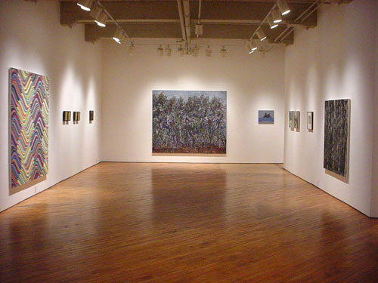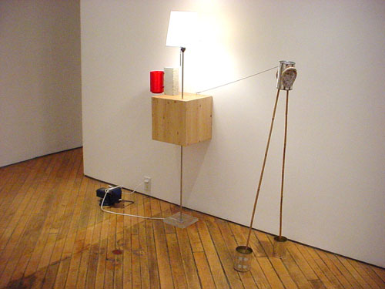

Stand installation, Northeast Gallery, Stand installation, Project Room,
l. to r. Angela Leach, Nicole Collins, Jonathan Johnson, Ted Rettig,
Monica Tap, Kim Ouellette, Carroll Taylor Lindoe,
Doris McCarthy, Gerald Ferguson.
For more show images see current exhibitions at; www.wynicktuckgallery.ca

Other Gallery Artists’ Projects and Announcements
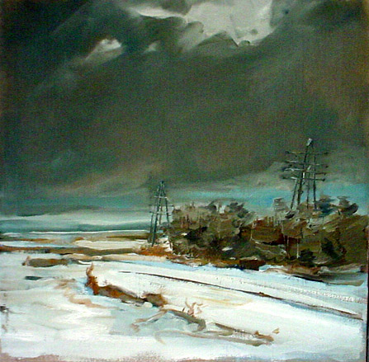
Johnson, Jonathan, Powerlines #2, 2004, 30” X 30” oil on linen

Jonathan Johnson, whose first solo exhibition at Wynick/Tuck Gallery will take place this coming September, has been nominated as one of the semi-finalists for the RBC Painting Competition. The competition is judged by some of the leading artists and curators in Canada, and the winners will be announced this coming September. Congratulations Jonathan! Jonathan’s first solo exhibition at Wynick/Tuck Gallery opens September 9, 2006

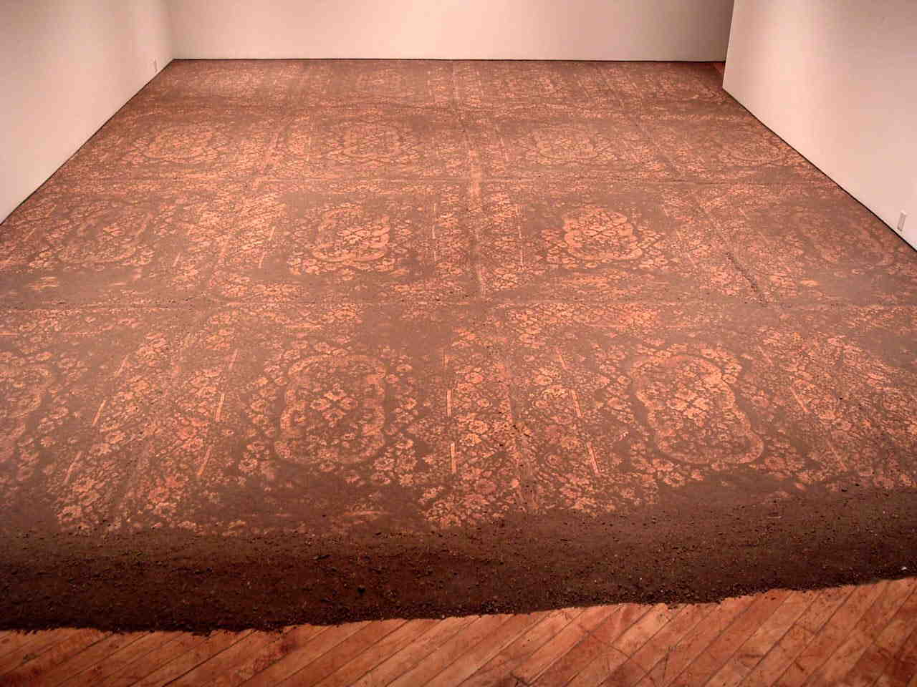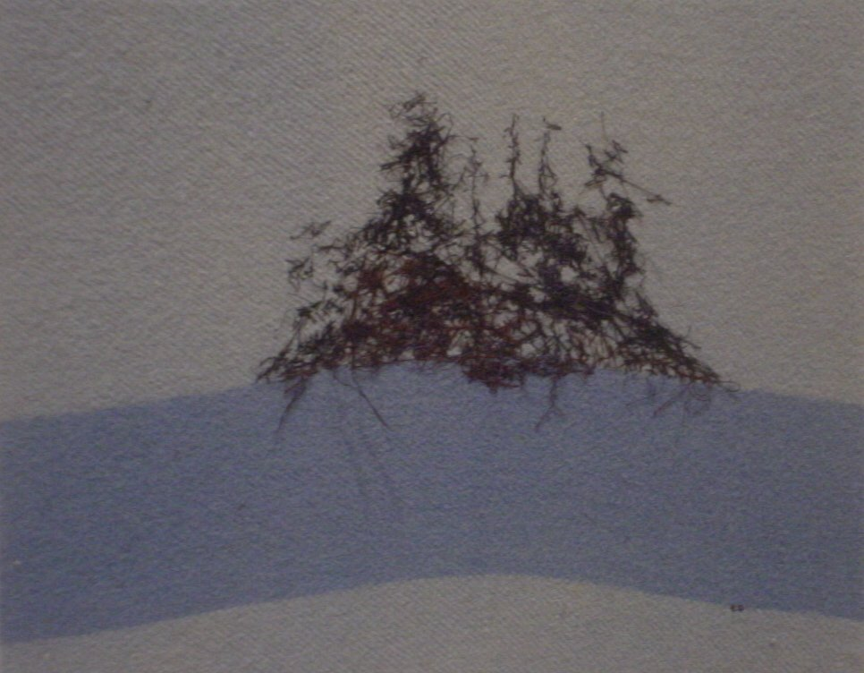

Lane, Cal, Dirt Lace Installation (2004) Ouellette, Kim, Tangled in Blue (2005)
variable dimensions, dirt 16” x 20”, thread on blanket

Gallery artists Cal Lane and Kim Ouellette are both part of the group exhibition Fray opening at the Textile Museum and Koffler Centre, Toronto, July 13. The exhibition runs through January 7, 2007.

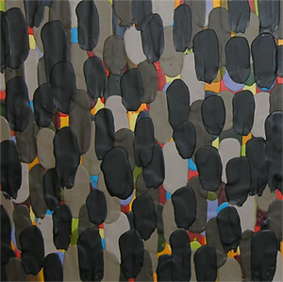
Nicole Collins, oil and wax on canvas

Gallery artist Nicole Collins is part of a three-person show entitled Collins. White. Waldburger.: Wax at the Elora Centre for the Arts in Elora, Ontario. The exhibition opens this Thursday, July 13 at 7:30 pm, and workshops with the artists take place on July 14, 15 and 16. The exhibition runs from July 13 – August 12.

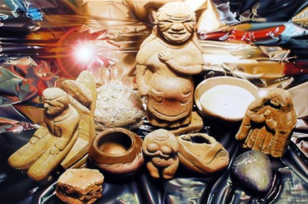
Hall, John, Burst (2006), acrylic on canvas, 24” x 36”

Gallery artist John Hall is part of a new two-person exhibition opening this Friday, July 14 at the Art Gallery of the South Okanagan in Okanagan, BC, entitled Mimesis: Paintings by Joice M. Hall and John Hall.

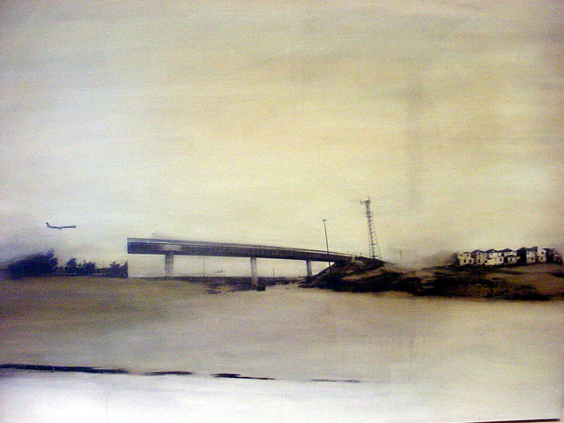
Shoub, Jaclyn, At This Point in Time #3 (2004), oil & toner on mylar mounted on board, 9” X 16”

Gallery artist Jaclyn Shoub is currently part of a major exhibition at the Canadian Museum of Contemporary Photography, part of the National Gallery of Canada, entitled The Painted Photograph. The exhibition runs from May 5 – November 19, 2006.

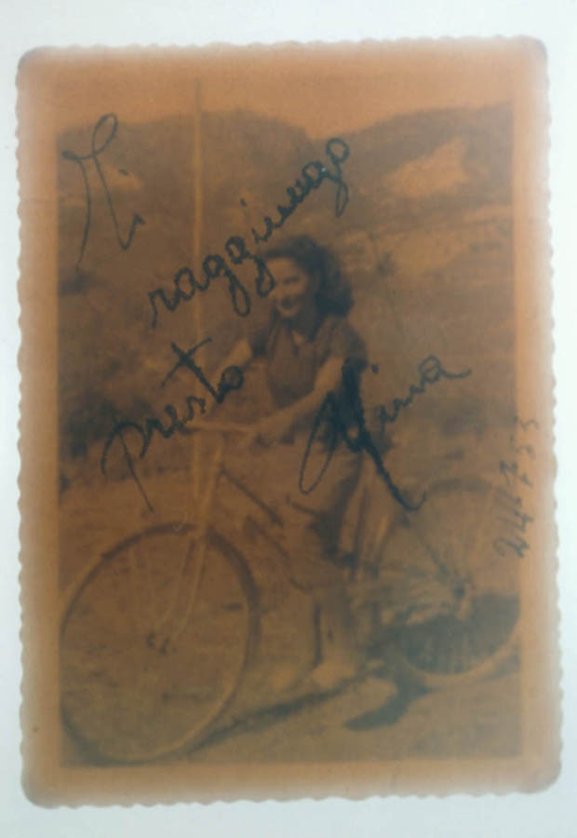
Angelucci, Sara, Al Riverso Series (Bicycle), Ed. 1/5 (2003), c print, 37 ½ ” X 28 ½ ”

Artist Sara Angelucci’s works from the Al Riverso series are featured as part of a group exhibition entitled ‘Tween Heart and Mine at the Modern Fuel Artist-Run Centre in Kingston, ON, from June 7–July 15, 2006.

For more information: Katrina Enros, 416-504-8716 x21
Please visit, www.wynicktuckgallery.ca

