For Immediate release, May 5, 2006.

Dianne Bos
Apparitions
as part of the Contact Photography Festival
New photographs
May 6 – May 27, 2006
North Gallery

Opens Saturday, May 6th, with artist present from 2 – 5 pm

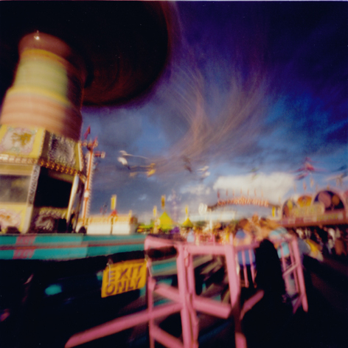

Bos, Dianne
Stampede Midway 3 (exit), Calgary, 2004 A/P
Archival ink jet print on acid free paper
40” X 40”

Wynick/Tuck Gallery is pleased to announce the opening of Dianne Bos’ latest exhibition, Apparitions, presented as part of the Contact Festival of Photography. Contact, currently celebrating its tenth year, chose Dianne’s exhibition as one of the festival features, demonstrating this year’s theme, Imaging a Global Culture. For further information, please refer to p. 75 of the CONTACT Toronto Photography Festival Catalogue.

Dianne explains the choice of the title Apparitions: “In my pinhole photographs, all that remains on film is the trace left by what people have built or carved or manipulated (in the form of gardens, sculpture or architecture). The passing human figure normally disappears, or lingers only in ghostly form.” The exhibition features works shot at the Calgary Stampede, as well as various locales in France and Italy.

Dianne’s solo exhibition Time and Space will open in November 2006 at the University of Lethbridge Art Gallery, and her Vimy Ridge series will also show at the Confederation Centre, PEI this upcoming Fall. Dianne plans to retreat for five months to her studio in France this autumn to work on a new series.

.

Greg Curnoe
Selected Collages, Watercolours, Mixed Media and Stamped Ink on Paper, 1962-1992
Project Room

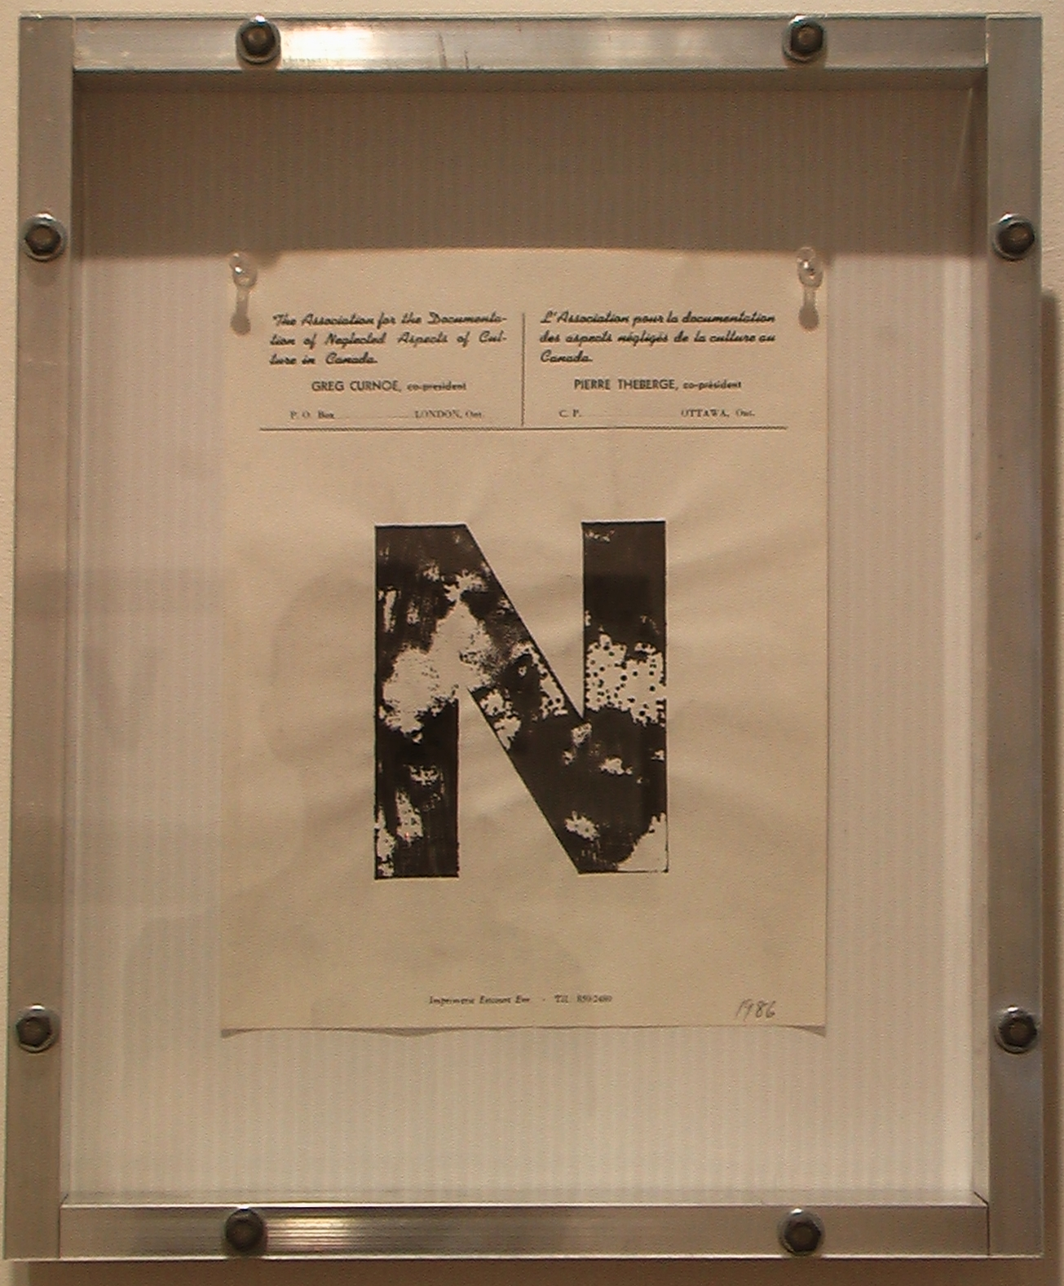

Curnoe, Greg
“N”, 1986
stamp pad ink on paper
8 ½” X 11”

Last month’s exhibition of Curnoe works will, in part, be held over in the Project Room, and will highlight some selections from his rubber stamp series.

Other Gallery Artists’ Projects

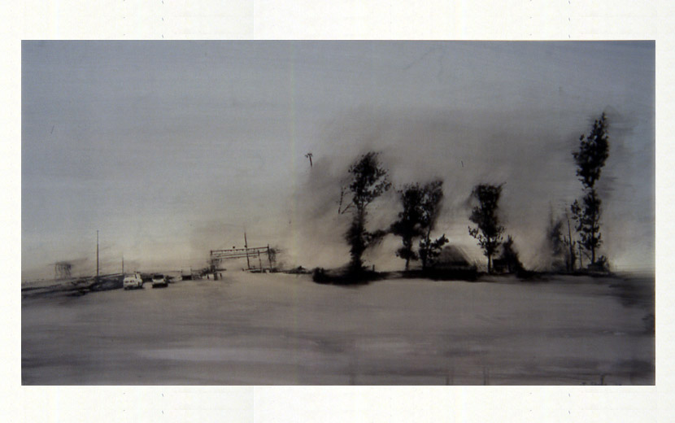
Shoub, Jaclyn.
Study for Landscape with Trees (blue version), 2004
oil & toner on mylar mounted on board
9 X 16 in.

Gallery artist Jaclyn Shoub will be part of a major exhibition which opens today at the Canadian Museum of Contemporary Photography, part of the National Gallery of Canada, entitled The Painted Photograph. The exhibition runs from May 5 – November 19, 2006.

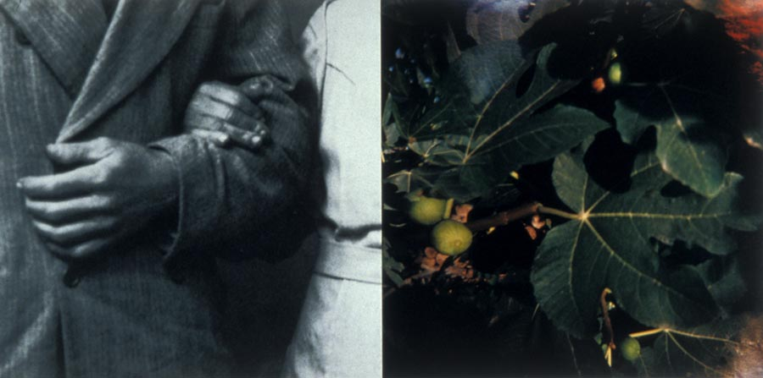

Angelucci, Sara
Stillness #3 (Figs), Ed. 2/5, 2003
silver gelatin and chromeogenic print
34 ¼ X 49 in.

Artist Sara Angelucci’s exhibition, Somewhere in Between at Cambridge Galleries, continues to May 14, 2006. The show features works from her Stillness and Al Riverso series.

For more information: Katrina Enros, 416-504-8716 x21
Please visit, www.wynicktuckgallery.ca

